**HTML**

1. **HTML:** HTML stands for Hyper Text Markup Language.
2. It is used to give structure and format to our web page.Like bold , italic, underline , etc.
3. To view web page source -> right click on browser -> inspect.

**Basic structure of HTML**

<html>

    <head>

        <title>This is title</title>

    </head>

    <body>

        <p>

            Hello world

        </p>

    </body>

</html>

**HTML Elements**

**HTML elements** are the building blocks of web pages. An HTML element consists of a start tag, content, and an end tag. Elements represent different parts of a webpage, such as headings, paragraphs, links, and images. For example, a paragraph element is written as <p>This is a paragraph.</p>, where <p> is the start tag, "This is a paragraph." is the content, and </p> is the end tag. Elements can also have attributes that provide additional information, such as <a href="https://example.com">Visit</a>, where href specifies the link destination.

**Paragraph element (<p>):** The <p> tag defines a paragraph in HTML and is used to group sentences and separate text blocks for readability. By default, browsers add space before and after each paragraph, and each <p> element starts on a new line. Example: <p>This is a paragraph.</p>.

**Heading element (<h1> to <h6>):** Heading tags define headings of different levels, from <h1> (most important, usually the page title) to <h6> (least important). Headings help organize content hierarchically and improve accessibility and SEO. Example: <h1>Main Title</h1>.

**Bold element (<b>):** The <b> tag makes enclosed text bold without adding extra importance. For greater emphasis, use <strong>. Example: <b>This text is bold.</b>.

**HTML Tags**

**HTML tags** are special text identifiers enclosed in angle brackets, like <tagname>, used to define and structure elements within an HTML document. Most tags appear in pairs: an opening tag (e.g., <p>) starts an element, while a closing tag (e.g., </p>) ends it. For example, <h1>Hello</h1> creates a level-one heading with the text "Hello". Some tags are self-closing, like <img> or <br>, and do not require a closing tag. Tags provide instructions to the browser on how to display content, and are essential for marking headings, paragraphs, images, links, and more.

**HTML extension**

‘.html’ is extension for a html file

**Practice Question 1**

Generate following web page using html.

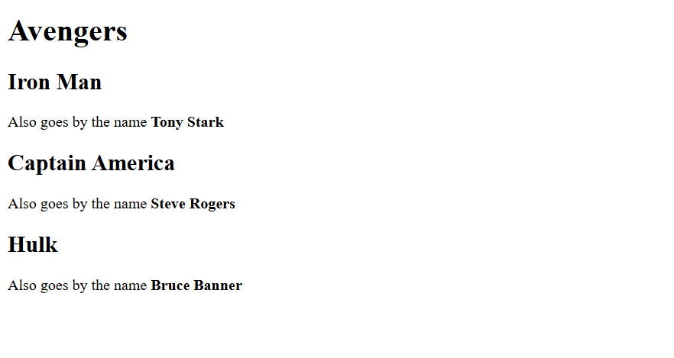

<!DOCTYPE html>

<html lang="en">

<head>

    <meta charset="UTF-8">

    <meta name="viewport" content="width=device-width, initial-scale=1.0">

    <title>Avengers</title>

</head>

<body>

    <h1>Avengers</h1>

    <h2>Iron Man</h2>

    <p>Also goes by the name <b>Tony Stark</b> </p>

    <h2>Captain America</h2>

    <p>Also goes by the name <b>Steve Rogers</b> </p>

    <h2>Hulk</h2>

    <p>Also goes by the name <b>Bruce Banner</b> </p>

</body>